LAB NASM data and bss examples and problems (NASM/Linux Platform)

# Part One: Data section declaration, and how it is stored in memory

DB is 8 bits

DW is 16 bits

DD is 32 bits

### Exercise #1a

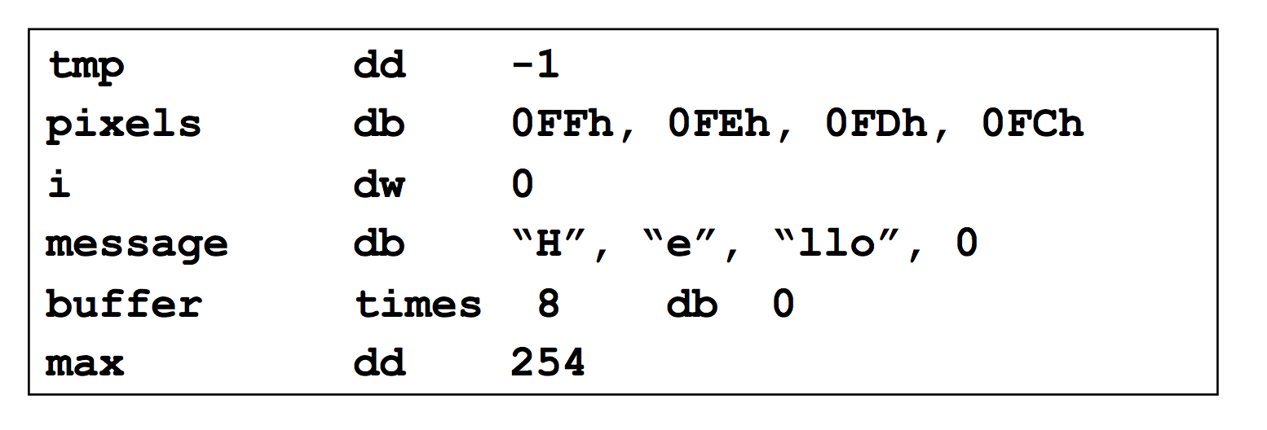

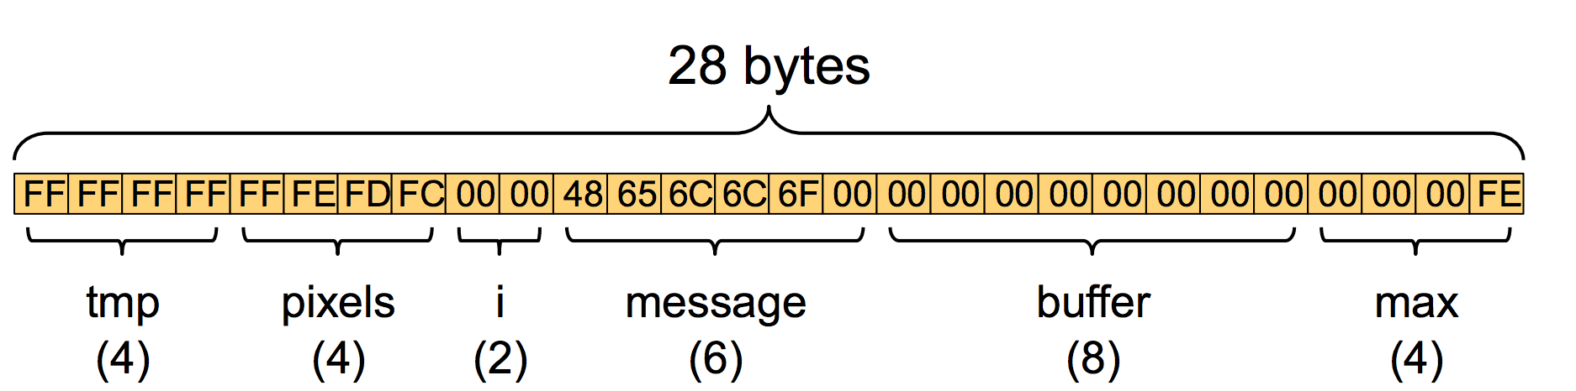

* nasm -felf64 ex1a.asm -l ex1a.lst

### Exercise #1b

What is the layout and content of the data memory segment on a Little Endian Machine? Byte per byte, in hex.

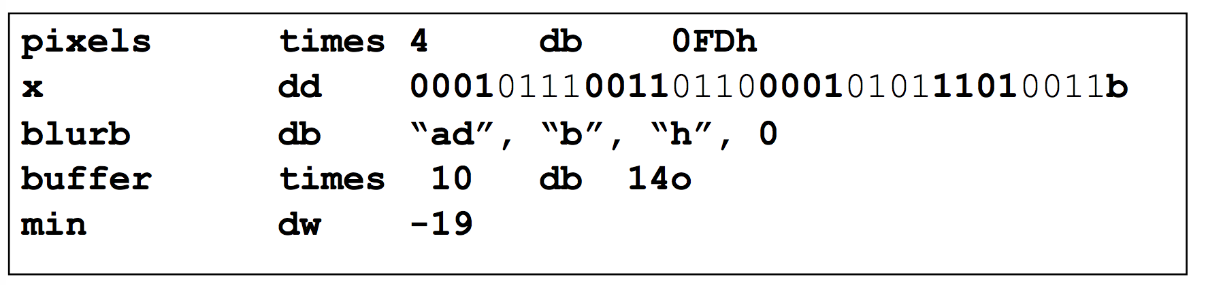

### Exercise #1c

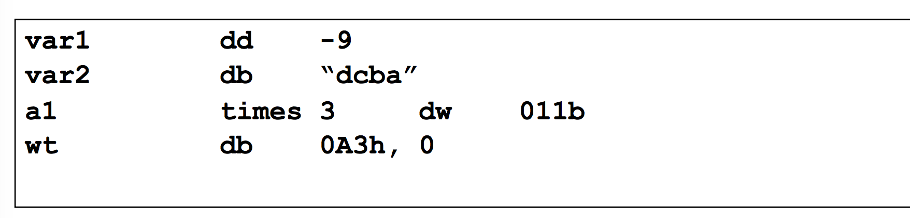

### Exercise #1d

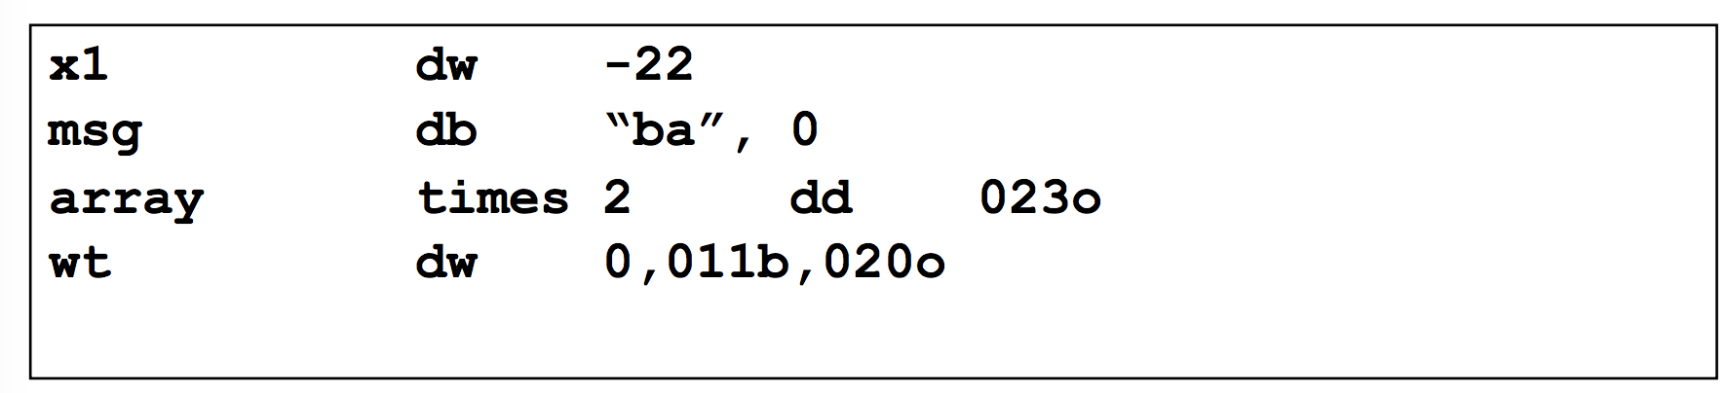

# Part Two: Involving register indirect, or memory indirect

These exercises use a nasm library that contain useful functions from “PC Assembly Language” textbook resource; so we can “dump_mem”, and “print_string” for example. The library files you need are asm_io.inc, and asm_io.asm; I have put those files in D2L.

### Exercise #2a

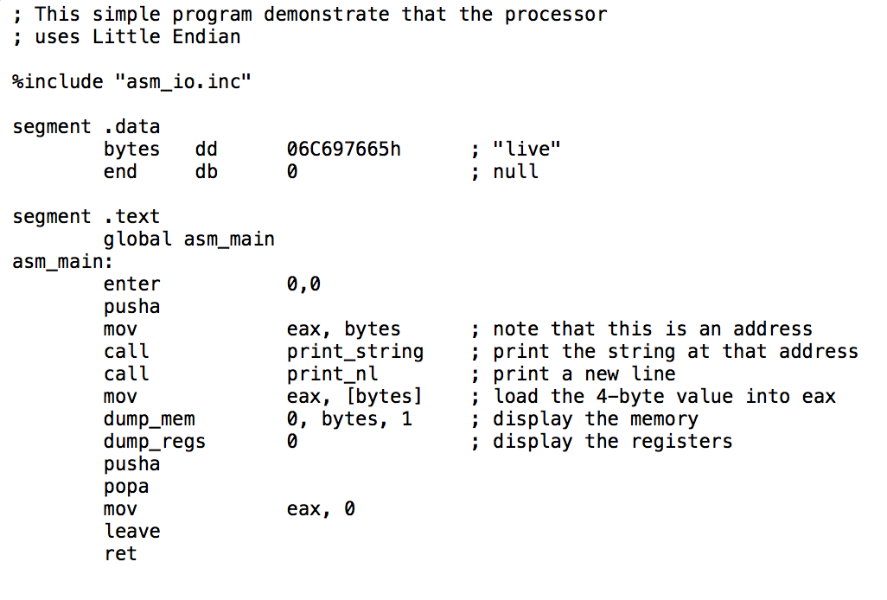

* nasm -felf32 -d ELF_TYPE asm_io.asm
* nasm -felf32 -d ELF_TYPE ex2a.asm
* gcc -m32 driver.c ex2a.asm asm_io.o
* ./a.out

### Exercise #2b

What is the in-register byte-order and the in-memory byte order?

First line involves immediate data addressing mode. No memory access is involved.

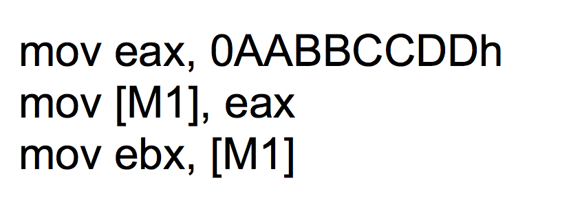

### c. Exercise #2c

What is the in-register byte-order and the in-memory byte order?

